Order Of Service

Singing: Psalm 47—CW page 85

Reading: Psalm 30

Opening Hymn: TLH 94

Reading: Revelation 12

Request Hymn: CW Supplement 707

Reading: John 7:25-31

Sermon Hymn: TLH 339

Sermon Text: Song Of Solomon 5:9

Why Him ???

Prayer

The Apostles’ Creed, TLH page 12

Holy Communion

The Lord's Prayer

The Blessing

Closing Hymn: TLH 97

* * * * * * * * * * *

Bible Study: Lambs: I Samuel 17:44-45; The Battle Is The Lord’s
Sheep: Proverbs 12:14-19
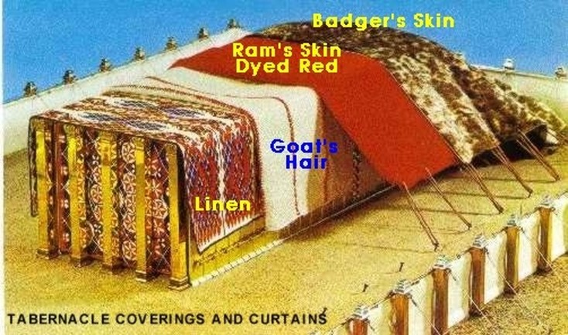

Tabernacle Coverings

Water
Of
Life

15 January 2017

W A T E R O F L I F E

Independent Christian Church—Conservative Lutheran Doctrine

Worship Service: 9:30 a.m. Bible Study: 10:45 a.m.

Larry Cooper, Pastor E-Mail address:
111 N. Ridge Road lcooper@wateroflife.cc
Coon Valley, WI 54623 Web Site:
Phone: (608) 452-2105 www.wateroflife.cc

* * * * * * * * * * * * * * * * * * * * * * * * * * *

Sermon Text: Song Of Solomon 5:9

Why Him ???

* * * * * * * * * * * * * * * * * * * * * * * * * * *

Song of Solomon 5:9 What is thy beloved more than another beloved, O thou fairest among women? what is thy beloved more than another beloved, that thou dost so charge us?

Related Reading: Isaiah 1

:10 Hear the word of the LORD, ye rulers of Sodom; give ear unto the law of our God, ye people of Gomorrah.
:11 To what purpose is the multitude of your sacrifices unto me? saith the LORD: I am full of the burnt offerings of rams, and the fat of fed beasts; and I delight not in the blood of bullocks, or of lambs, or of he goats.
:12 When ye come to appear before me, who hath required this at your hand, to tread my courts?
:13 Bring no more vain oblations; incense is an abomination unto me; the new moons and sabbaths, the calling of assemblies, I cannot away with; it is iniquity, even the solemn meeting.
:14 Your new moons and your appointed feasts my soul hateth: they are a trouble unto me; I am weary to bear them.
:15 And when ye spread forth your hands, I will hide mine eyes from you: yea, when ye make many prayers, I will not hear: your hands are full of blood.



